EXP NO 1:

CREATE A SIMPLE CLOUD SOFTWARE APPLICATION AND PROVIDE IT AS A SERVICE USING ANY CLOUD SERVICE PROVIDER TO DEMONSTRATE SOFTWARE AS A SERVICE (SAAS)

AIM: Implement cloud software Application using Zoho.com

PROCEDURE:

* define what SaaS applications are and tell about their advantages
* describe the process of SaaS application development step by step
* point out important things to keep in mind when building your software as a service app
* give a rough cost estimate for cloud-based SaaS [app development](https://clockwise.software/blog/app-development-cost/).

IMPLEMENTATION:

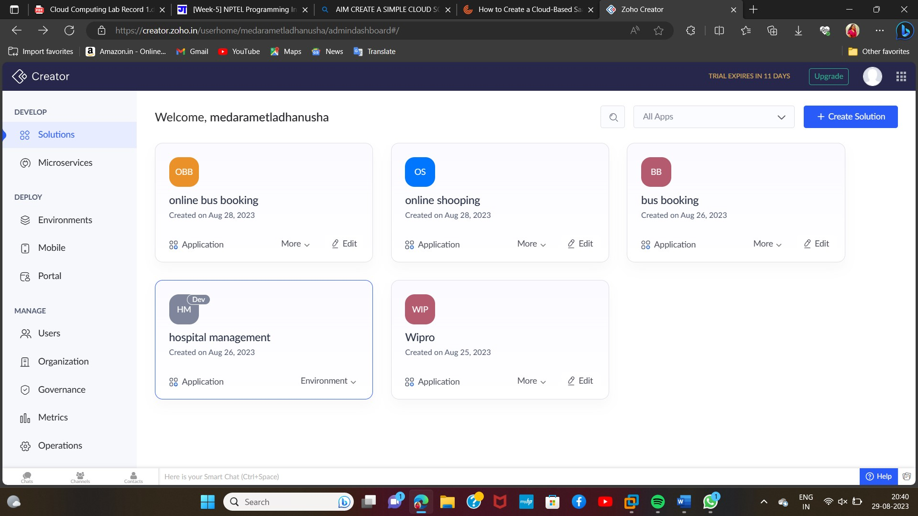

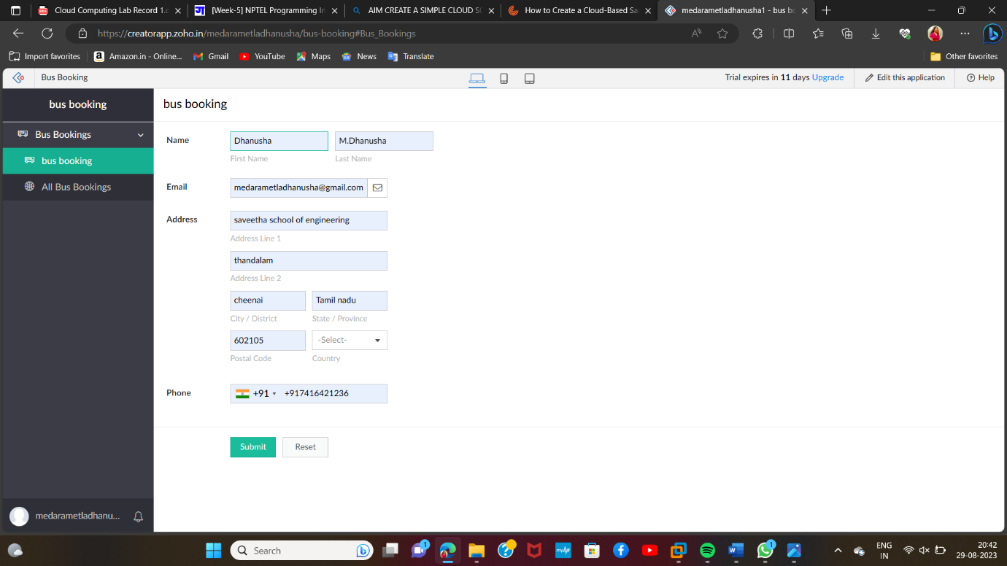

Result: successfully implemented zoho.com